This week I’ve learnt about basics of queueing as well as fundamental usages of Microsoft Excel.

One thing that I learnt about excel was how to manipulate functions to make charts. In addition to that I learnt the basics of creating a graph like what kind of graphs excel supports and how to choose a set of data for the axis of that particular graph.

But more importantly I learnt about the principal theorems which are the basis queueing theorem. The most essential thing that we learnt, in my opinion, was that “**No jobs are created or destroyed in the system**”.

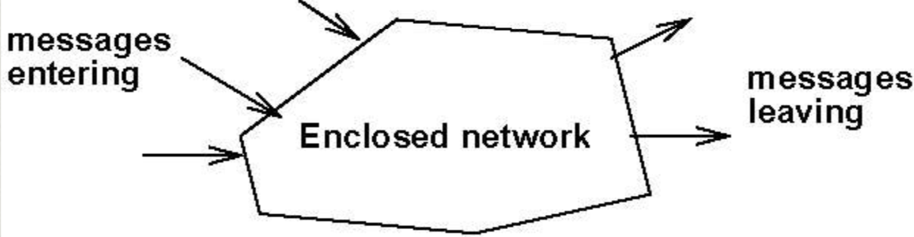

Another interesting thing that I learnt was that queues are caused by variations of things like variation in arrival of people or objects or the variation in service that is represented to those people.to overcome this complexity we create a simpler model by taking the average rate of arrival λ and average rate of service μ . this simplification allows us to overcome the predictable model to serve all the costumers, but the problem is that the variation means that these two factors are random in real life however they can be analyzed. We did not go in depth with the analysis but some of the things that I learnt were little’s law and different states that a queue can be in. A queue can be in a transient state or a stable state. Transient state is usually the initial queue that is formed in the morning or at the beginning of the day. A stable state is when average input rate equals average output rate.

We then learnt about the load on the system and how it is affected by average rate of arrival and average rate of service. As the average rate of arrival increases load increases and as the average rate of service increases the load decreases. The load can never be higher than 1 otherwise the system is no longer stable, and the number of arrivals is higher than number of departures.

We also learnt about queues in computer. We learnt how prioritizing and sometimes rejecting the overload of tasks can help a server to work faster which was interesting to me and how buffers interact with servers. We also understood there’s a limit to server’s speed and when the limit is reached we have to increase the number of servers , the fact that this will only work if we have several costumers that want to access their data simultaneously really shocked me because I didn’t know that.